SQL Analysis Report

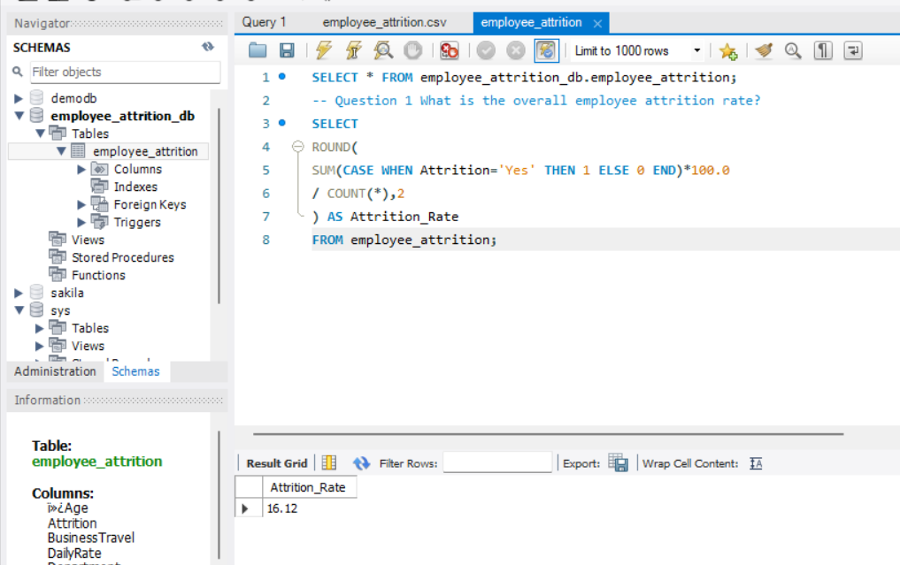
- The overall employee attrition rate is 16.12%, indicating that approximately 16 out of every 100 employees leave the organization. This suggests a moderate turnover rate and highlights the need for proactive employee retention strategies.

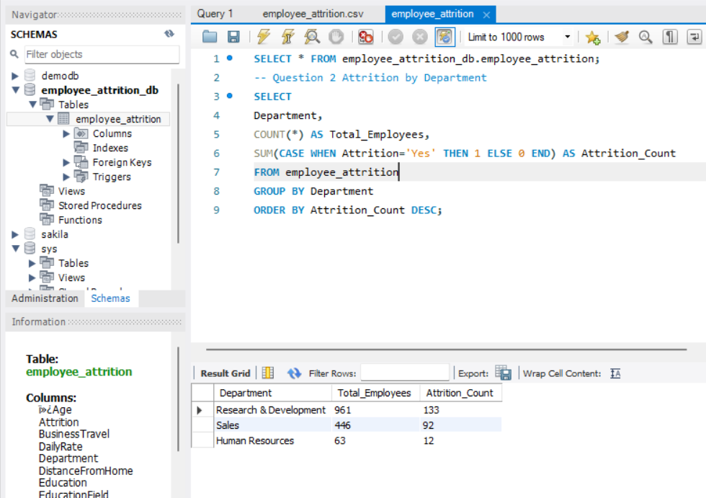
- The Research & Development department recorded the highest attrition count (133 employees), followed by Sales (92 employees) and Human Resources (12 employees). Retention initiatives should primarily focus on the Research & Development function.

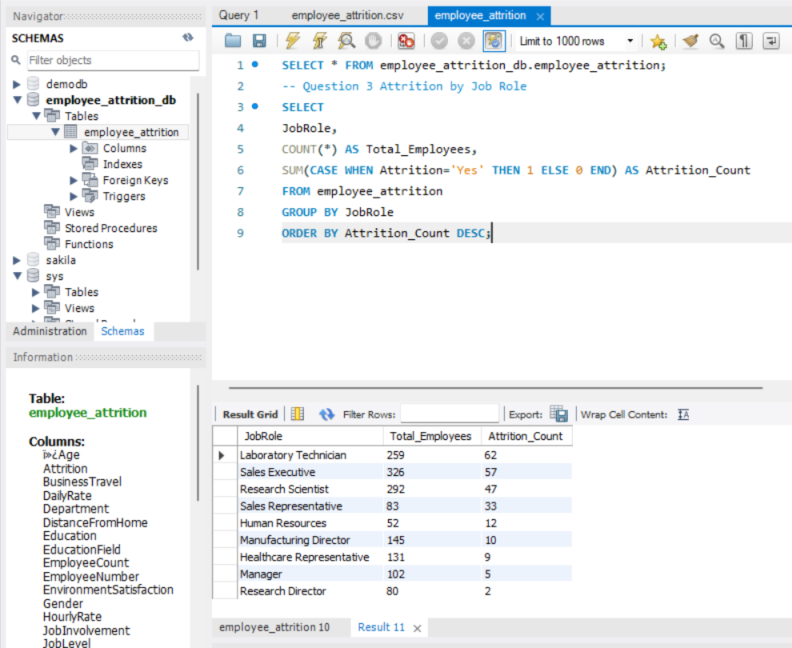
- Laboratory Technicians (62), Sales Executives (57), and Research Scientists (47) experienced the highest employee turnover. These roles should be prioritized for engagement and retention programs.

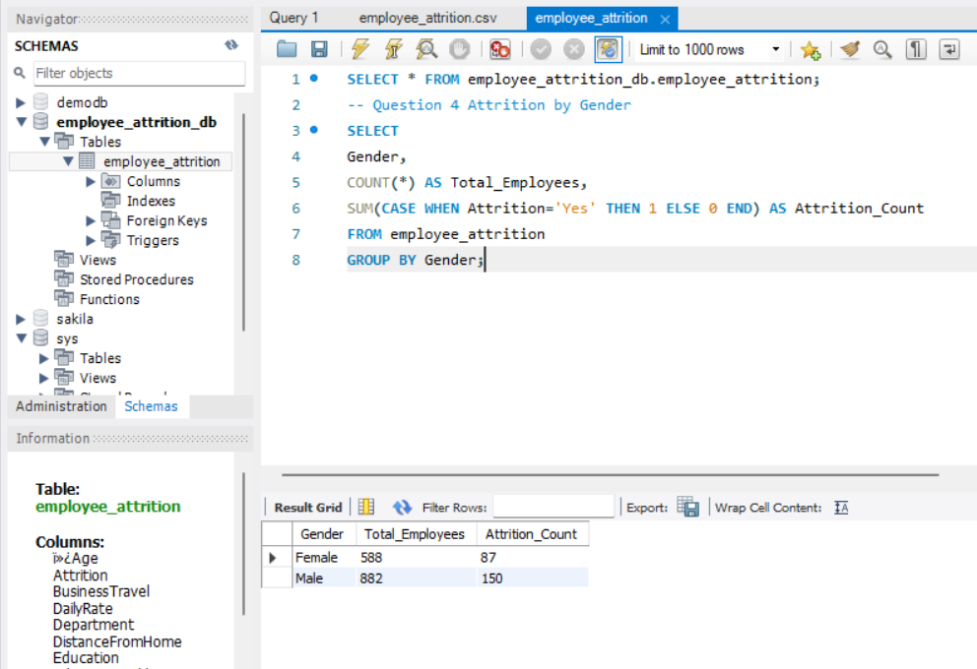

- Male employees accounted for 150 attrition cases, while female employees accounted for 87 attrition cases. This indicates a higher turnover volume among male employees and may require further analysis of role distribution and workplace factors.

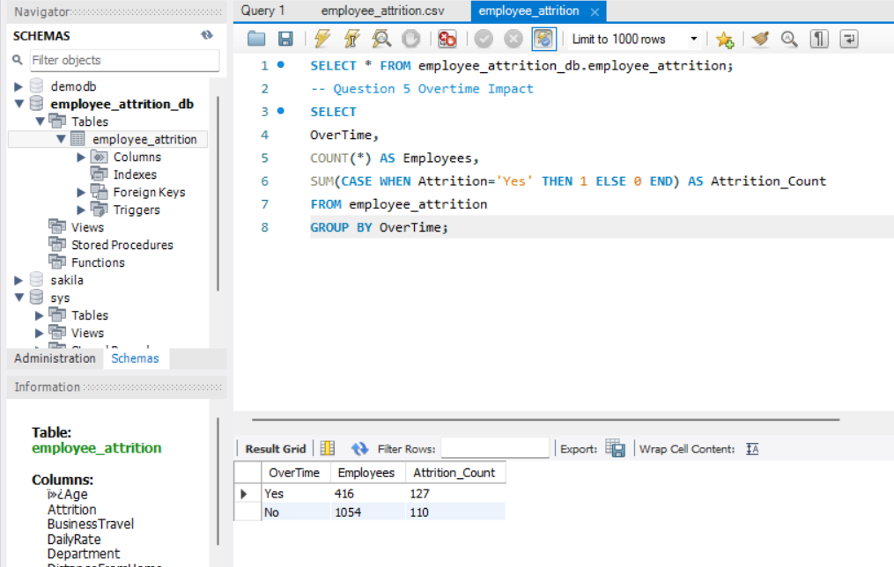
- Employees working overtime showed significantly higher attrition (127 employees) compared to employees who did not work overtime (110 employees), despite the overtime group being much smaller. This suggests that excessive workload is a major contributor to employee turnover.

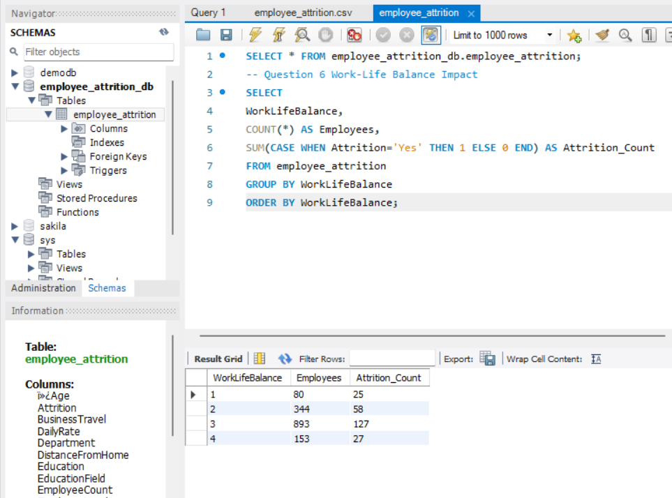
- Employees with lower work-life balance ratings exhibited higher attrition levels. Employees rated at level 3 recorded the highest attrition count (127 employees), indicating that work-life balance is an important factor influencing employee retention.

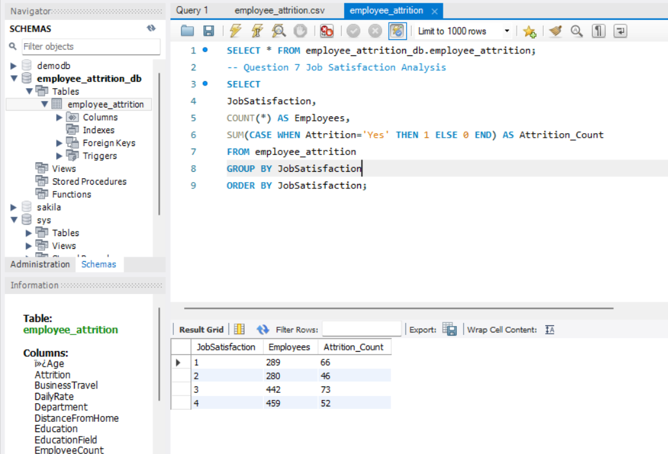

- Employees with lower job satisfaction levels experienced higher attrition. Job satisfaction level 3 recorded the highest attrition count (73 employees), highlighting the importance of employee engagement and satisfaction initiatives.

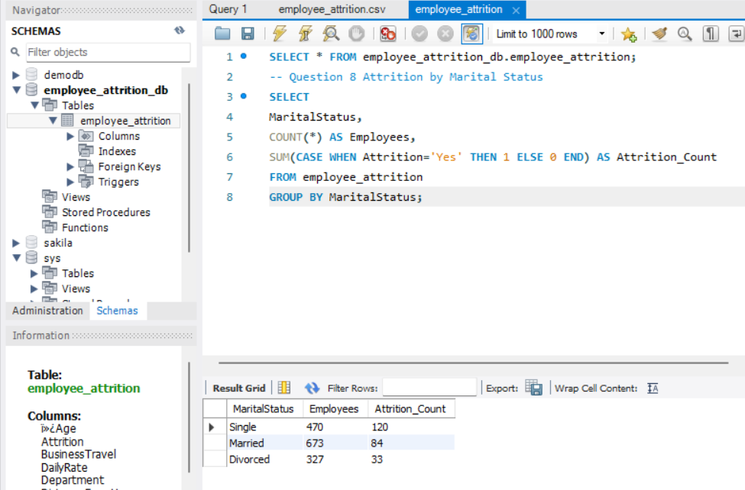
- Employees with lower job satisfaction levels experienced higher attrition. Job satisfaction level 3 recorded the highest attrition count (73 employees), highlighting the importance of employee engagement and satisfaction initiatives.

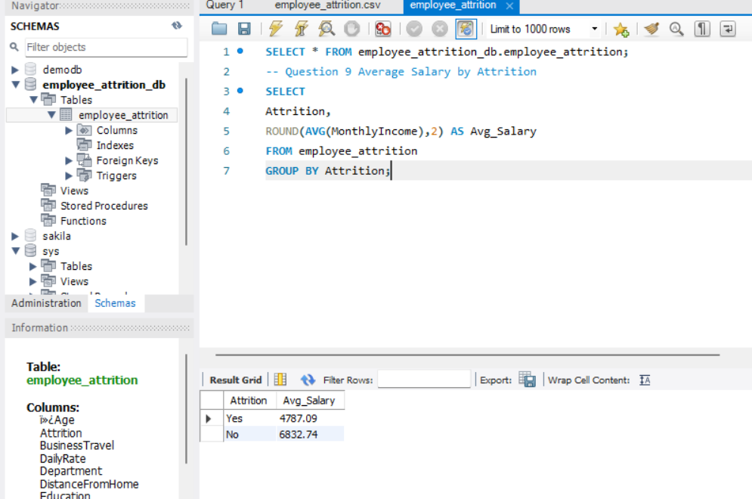

- Employees who left the organization had an average monthly income of approximately ₹4,787, whereas retained employees earned approximately ₹6,833. This indicates that compensation may play a significant role in employee retention decisions.

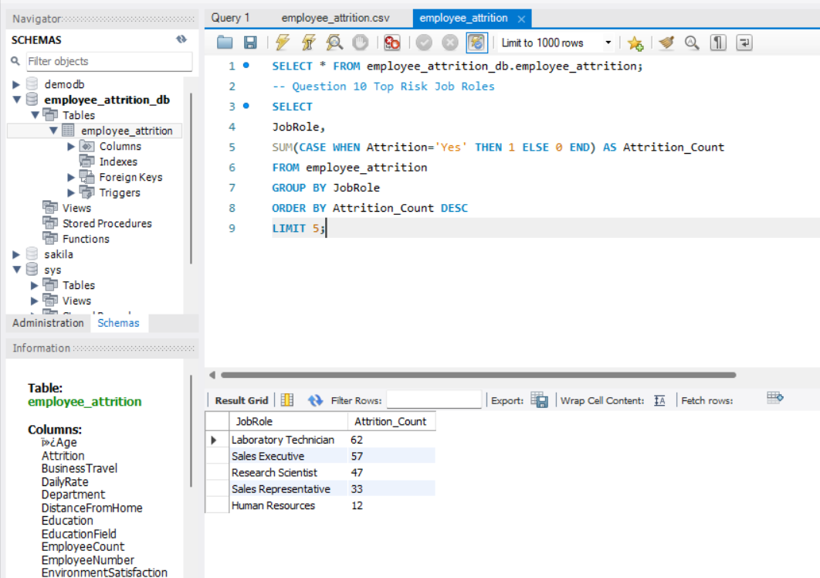

- The highest-risk job roles for attrition are Laboratory Technician, Sales Executive, Research Scientist, Sales Representative, and Human Resources. HR should prioritize these roles for retention planning and employee engagement initiatives

